## **Final Exam- Comp1350, S2 2020**

|  |  |
| --- | --- |
| Student ID |  |
| Student Name |  |
| Subject Code | COMP1350 |

~~**Delete this sentence: Please rename your document to your StudentID_StudentName**~~

Section-A

1. EER Diagram:

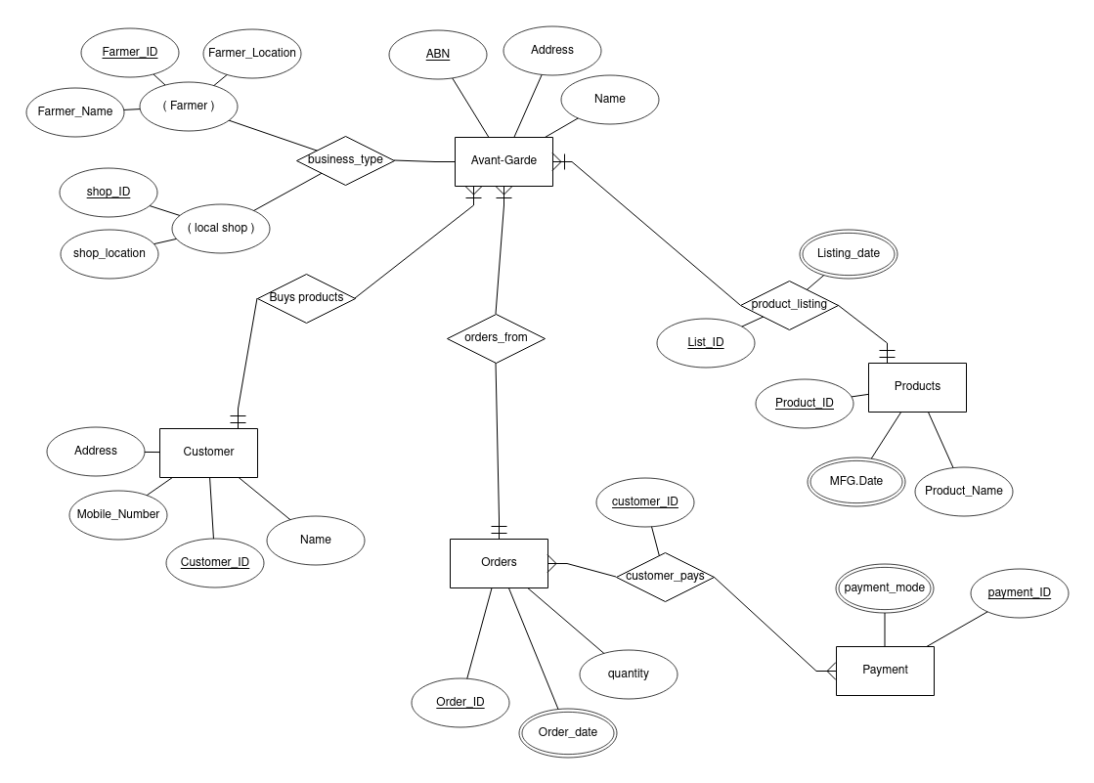

The case study has been very informative in drawing the ER Diagram, everything was clearly explained in it. I have implemented everything that was mentioned to be done. I additionally included a payemnt entity to store the transaction information of the customer. This is my assumption to make the system work better and store data organised considering that the customer can multiple payments through single payment_ID. If we have method to organise and store the payment information on the basis of payment_ID, it’ll give a better data results.

Explanation of concepts:

* 1. Strong Entities have primary keys, whereas weak entities don’t have primary keys. They depend on the strong entities.

Strong Entites – Customer_ID in customer table is an example of strong entities.

Weak Entites – Customer_ID in payment table is an example of composite primary key which is the foreign key. This is an example of weak entity.

* 1. An associative entity is the table that associates two other tables in a many to many relationship. An associative relationship attribute is an attribute of the associative entity that exists because of the many to many relationship.

Example of assosiative entity is the relation customer_pays to the order he makes.

* 1. A composite attribute means that they can be further divided into meaningful sub-attributes, like in the above table you can see Type of business is sub-divided into farmer and local shop.

Example of composite attribute is the business_types which is sub-divided into farmer and local_shops which can further be sub-divided into meaningful attributes.

* 1. A multivalued attribute can have more than one value at a time for an attribute. Like the address can have multiple values.
  2. Total Participation − Each entity is involved in the relationship. Total participation is represented by double lines. Partial participation − Not all entities are involved in the relationship. Partial participation is represented by single lines.

1. Logical Transformation:

Step-1 : Strong Entities

**Orders(**Oder_ID(pk), quantity, Order_date, price**)**.

**ProductListing(** product_lisiting_ID(pk), product_listing_date**)**.

Step-2 : Weak Entities

**Order(**Customer_ID(fk)**)**

Step-3 : One-One Relationship

There are no one-one relationships in the table.

Step-4 : One-many Relationship

**productListing(**product_listing_ID(pk),product_listing_date**)**

**Orders(**Order_ID(pk), quantity, Order_date, Customer_ID**)**

Step-5 : Many-many Relationship

There exists a many-many relationship between oders and payment entities.

**customer_pays(**customer_ID(pk), payment_ID(pk,fk)**)**

Step-6 : Multi-values Attributes

**Orders(** Customer_ID(pk,fk), price**)**

Step-7 : Ternary Relationship

**Orders(** Order_ID(pk,fk), Customer_ID(pk,fk), payment_ID(pk,fk), quantity**)**

Step-8 : Final Tables

**Orders(** Order_ID(pk,fk), Customer_ID(pk,fk), payment_ID(pk,fk), quantity, price, Order_date**)**

**Product_Listing(** Product_listing_ID(pk), Product_listing_date**)**.

1. Anomalies Explanation:

There are 3 different types of anomalies namely insertion, deletion and update.

|  |  |  |  |  |  |
| --- | --- | --- | --- | --- | --- |
| FarmerID | ProduceID | FarmerName | FarmLocation | ProduceName | Price per kilo |
| F1 | P1 | Claire’s Farm | NSW | Tomato | $7.99 |
| F1 | P2 | Claire’s Farm | NSW | Zucchini | $2.00 |
| F2 | P1 | Star World | VIC | Tomato | $6.99 |
| F2 | P3 | Star World | VIC | Spinach | $20.75 |
| F2 | P4 | Start World | VIC | Orange | $1.99 |
| F1 | P4 | Claire’s Farm | NSW | Orange | $3.99 |
| F3 | P1 | Where Pigs Fly | VIC | Tomato | $5.50 |

Update anomaly – in the above table, we can observe that they are two different tables joined namely Farmer and Avarto-Garde. So, we cannot update these both at the same time. This would make the database redundant, so it cannot be done.

Deletion Anmoly – Like the update anamoly we cannot delete the values, this would lead to redundancy so it also can’t be done.

The same goes for Insertion Anamoly. We can’t insert the values.

Example:- The above table is in the form of FarmerID, ProduceID, FarmerName, FarmLocation, ProduceLocation, PricePerWt.

This is a join between Farmer and Produce tables. Not all the colummns are shown in the join. As we know we cannot apply update, delete and insert on the join. We have to apply them on the individual tables separately.

Section-B (Insert your SQL code under each of the questions)

1. Query 1:

SELECT FarmerName, FarmName, FarmLocation

FROM

Farmer WHERE FarmLocation=”NSW”;

1. Query 2:

SELECT * FROM Produce;

1. Query 3:

SELECT p.ProduceName, f.FarmerName, f.county

FROM produce p

LEFT JOIN farmer f on p.farmer_id = f.ProduceID

GROUP by f.id

ORDER BY p.Weight

1. Query 4:

SELECT p.ProduceName, f.FarmerName, f.county

FROM produce p

LEFT JOIN farmer f on p.farmer_id = f.ProduceID

GROUP by f.id

ORDER BY p.Weight WHERE p.Weight!=0

1. Query 5:

Select p.PricePerWeight

FROM produce p

LEFT JOIN FARMER f on p.farmer_id = f.farmer_ID

WHERE f.FARMERNAME = “Alex”

1. Query 6:

SELECT Farmer.FarmerName

FROM produce p

(Select from Farmer f on p.farm_id = f.id)

GROUP by f.id

ORDER BY f.farm_name

1. Query 7:

SELECT Farmer.FarmerName

FROM produce p

LEFT JOIN farms f on p.farm_id = f.id

GROUP by f.id

ORDER BY f.farm_name

Section-C

1. Question 1:

We have created a relational database on the Avant-Garde database. We have huge amount of data from which we can create different applications on the database. We can create a E-commerce application, payment application and web interface application. We can create a database storage application. We can apply data analytic properties on the dataset to get useful patterns for our business model. We can also create a interface application where the local stores can directly select and choose farmer products. This will help them a lot for growing their businesses.

1. Question 2:

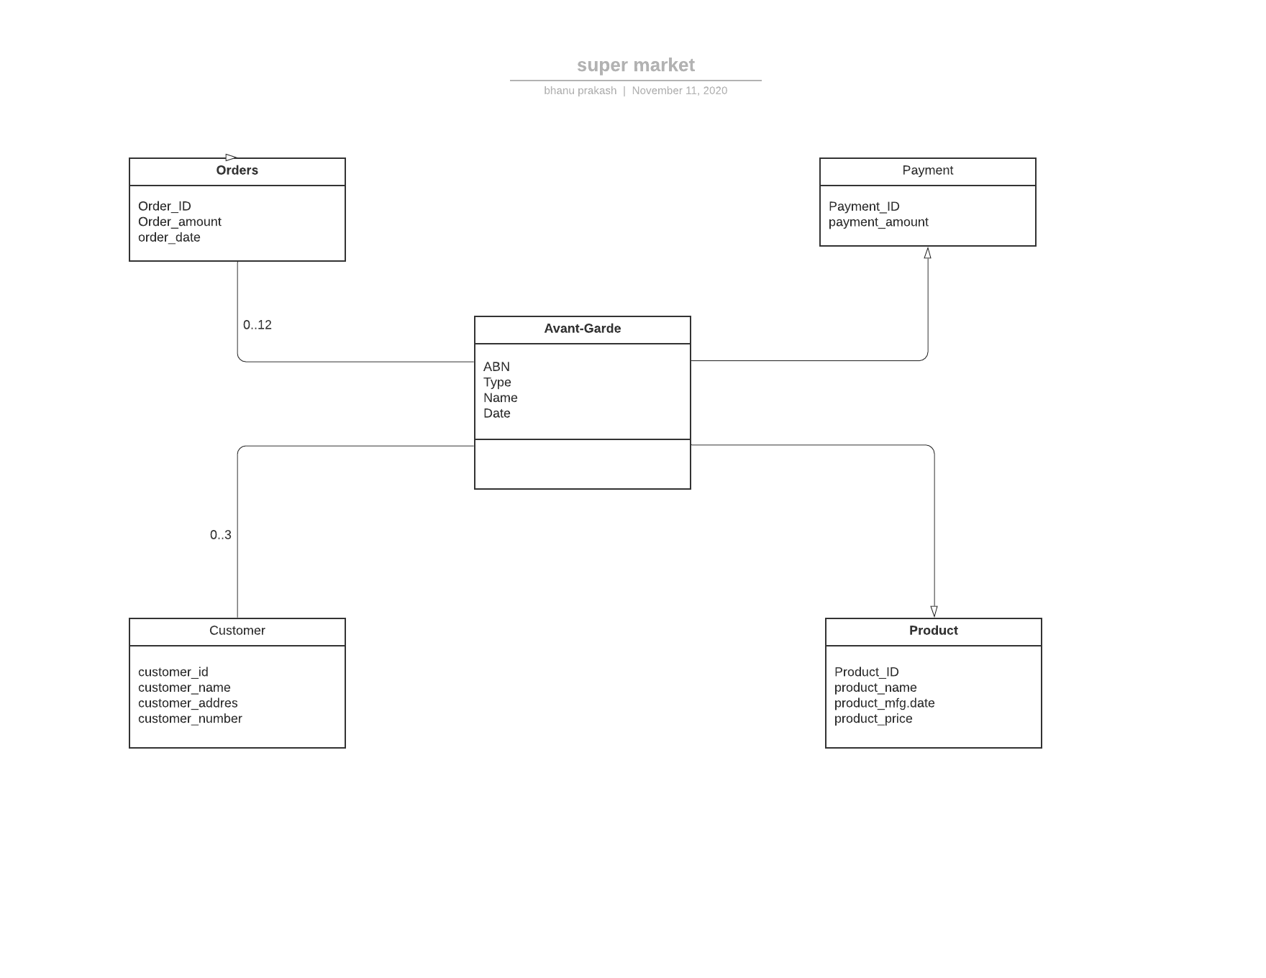

1. Question 3:

The above diagram represents a raw data reprenstaion of the data in star schema. We can analyse the data better and remove unwanted information from the database using datawarehouse. We can clean the data.

Question 3 :

Twitter has to store more data per day than it can reliably write to a single write using database. So it uses clusters to store data. As the relational database requires a large number of joins and insertions on a continous and very fast basis. It cannot depend on relational databases. Instead it uses Hadoop annd its own open-source database called FlockDB which is NoSQL db.